Spike Outcome Report

Number: 7

Spike Title: Emergent Group Behaviour

Personal: Michael Williams (7668481)

**Goals:**

* Include cohesion, separation and alignment steering behaviours
* Include basic wandering behaviours
* Use weighted-sum to combine all steering behaviours
* Support the adjustment of parameters for each steering force while running

**Technologies, Tools, and Resources used:**

* Python IDE
* Sample Lab Code
* Lecture Material

**Tasks undertaken:**

1. The first step undertaken was to study the lecture material and the provided sample code, to get an understanding of the way the current code worked, and what was required to complete the task.
2. From there, the stubs of the functions were implemented, using the lecture material as a basis.
3. Next, the stub functions were converted into fully functional behaviours one by one, using the following code:

**Cohesion**

**def** group_cohesion(self):  
 CentreMass = Vector2D()  
 SteeringForce = Vector2D()  
 AvgCount = 0  
 **for** bot **in** self.neighbours:  
 CentreMass += bot.pos  
 AvgCount += 1  
  
 **if** AvgCount > 0:  
 CentreMass /= float(AvgCount)  
 SteeringForce = self.seek(CentreMass)  
  
 **return** SteeringForce * self.max_speed

**Alignment**

**def** group_alignment(self):  
 AvgHeading = Vector2D()  
 AvgCount = 0  
  
 **for** bot **in** self.neighbours:  
 AvgHeading += bot.heading  
 AvgCount += 1  
  
 **if** AvgCount > 0:  
 AvgHeading /= float(AvgCount)  
 AvgHeading -= self.heading  
  
 **return** AvgHeading * self.max_speed

**Separation**

**def** group_separation(self):  
 SteeringForce = Vector2D()  
 **for** bot **in** self.neighbours:  
 ToBot = self.pos - bot.pos  
  
 *# scale based on inverse distance to neighbour* SteeringForce += ToBot / ToBot.length()  
  
 **return** SteeringForce * self.max_speed

1. Now that we had all of the behaviours, we just used simple vector addition multiplied by a scalar to combine these behaviours. The variable controlled to amount of weight that variable has on the overall behaviour of the agent. This was quite difficult to get right and in the end we may not have got it quite correct as you don’t always see all of the behaviours exhibited by the agents.
2. Finally, some key bindings were added (as below) to control all of these behaviours and how much weight they had.

**Key Bindings:**

* Pause: P
* Add Agent: +
* Remove agent: -
* Behaviours
  + Alignment: 8
  + Cohesion: 9
  + Separation: 0
* Group Variables
  + Alignment
    - Increase: Z
    - Decrease: X
  + Cohesion
    - Increase: C
    - Decrease: V
  + Wander
    - Increase: B
    - Decrease: N
* Show Info: I

**What we found out:**

After completing this spike, we learned that it is quite simple to get the basic behaviour for this up and running. Specifically, the individual components that make up the combined group behaviour, alignment, cohesion and separation. We did run into some trouble which we were unable to solve, where the cohesive behaviour would result in the agents spinning around each other trying to get to the centre. An improvement could have been made, where if the agent was within a certain distance of that group centre, to not move.

Overall, the outcome of this spike was positive, but more time spent fine tuning the individual behaviours using distance based calculations and speed adjustments would improve the agents, making them feel much more natural.

**Screenshots**

**Alignment**

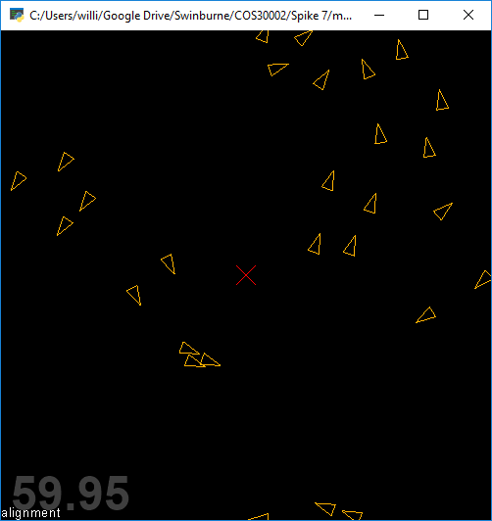

**Separation**

**Cohesion**

